(Approx. 670 words)

Two Interesting Office Tools
By Nancy DeMarte, 2nd Vice President, The Sarasota Technology Users Group, FL
August 2017 issue, Sarasota Monitor
www.thestug.org
ndemarte (at) verizon.net

With the new Windows 10 Creators update getting all the attention, it’s easy to miss the fact that Microsoft has also been rolling out new and improved features for Office gradually this spring and summer. They arrive as automatic updates to Office 365, the subscription version. I find them when I use an Office app or check the “What’s new?” section at the bottom of the Account section in any Office app file. (e.g., open Word> select a blank document> File > Account > What’s New?)

Here are a couple of the new tools you might be interested in:
Draw tab with Pens (for Word, Excel, and PowerPoint 2013 & 2016 in Office 365)

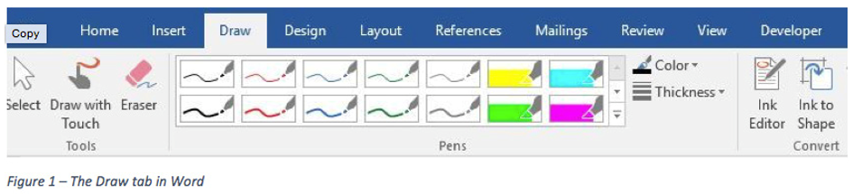

This set of pens, pencils and highlighters in Figure 1 was created for touch screens and pen-enabled devices. However, I found that I could use all the pens by clicking and dragging my mouse pointer on my non-touch laptop screen. To enable these pens, first add the Draw tab to the ribbon. Open the Word app, for example, and open a blank document. Click File > Options > Customize Ribbon, and then click the checkbox next to Draw in the right pane > OK. It will remain on the ribbon until you repeat this process and uncheck the box.

Click a pen or highlighter to select it; click again to deselect it. Click the Thickness and/or Color menus to customize the lines. Then draw, write, or highlight text with your finger, stylus or mouse, depending on your screen capability. Use the Ink Editor to mark up a draft document on the screen. Click the Convert to Shape tool and your next hand drawn circle will become perfect. If you don’t get an expected result, click the Eraser, and then click the pen marks to remove them. With a little practice, the Draw tab tools can enhance Word documents, PowerPoint slides, and Excel sheets or charts.

PowerPoint Designer (Office 2016 for Office 365 only) I find PowerPoint Designer very useful for creating professional-looking slides. Introduced in the fall of 2015, it has been improved and expanded through recent updates. Its purpose is to offer some optional design layouts for PowerPoint slides, like the Title or Title & Content slides. Once enabled, it activates when you insert up to 4 photos into a slide along with text. A menu of slide designs using your content appears to the right of the workspace. Click any layout to preview how it looks on your slide. (See Figure 2)

To use Designer, you must be connected to the Internet because the designs are located there. Also, you must be using one of the many PowerPoint design themes rather than one from a non-Office source or one you created yourself.
Figure 2 below is a PowerPoint Title slide using one of the design Ideas from the gallery. First, I chose a theme from the opening screen. Then I added Asheville, NC, as the title of the presentation and inserted a photo I had taken near there. Several design layouts showed up in the right pane. I chose this one.

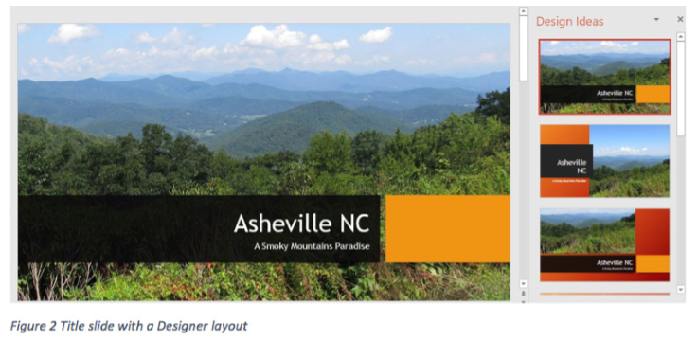

The Designer also offers ideas for text layout. For example, Figure 3 shows a slide on which I had typed a bulleted list of four things to do in Asheville. Then I chose this Smart Art layout from the Design Ideas menu. (The Smart Art tool is always available on the Insert tab in the Illustrations group.) If I wanted to return to my original layout, I could right click the Smart Art slide and select “Convert to Text.

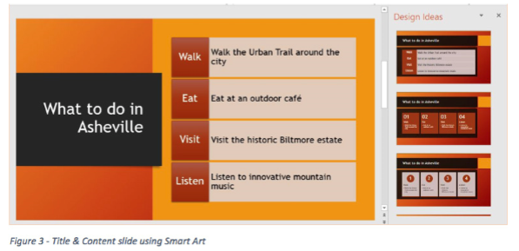

If you prefer not to see any Designer ideas, you can turn off the feature. With a PowerPoint slide open, click File > Options > General, and remove the checkmark next to “Automatically show me design ideas.” Stay tuned for more new Office tools and features in the future.

